MEB GROUP C_MATLAB ASSIGNMENT IV
No. | Name | Registration No.
1 | BABUWAGUZA SAMUEL | BU/UG/2025/05903
2 | LUBOWA NATHANEAL | BU/UG/2025/4433
3 | AKWI GLADYS ONYA | BU/UP/2025/3216
4 | KALANDA KENNETH | BU/UP/2025/1524
5 | WAMBI SAMUEL | BU/UP/2025/3227

The Assignment
- Solve the math questions using the Secant, Runge–Kutta and Newton–Raphson methods.
- Give solutions using both a “for” loop and a “while” loop for each of the equations.
- Draw a flowchart and write the pseudocode for each method.
- All the work is to be presented in Word and PowerPoint.

Question 1: Newton–Raphson Method
Use Newton’s method to find the zeros of f(x) = 1 − 3x + ½ x e^{x} accurate to five decimal places.
Newton–Raphson formula: x_{n+1} = x_{n} − f(x_{n}) / f′(x_{n})
f(x) = 1 − 3x + ½ x e^{x} ⇒ f′(x) = ½ (1 + x) e^{x} − 3
x_{n+1} = x_{n} − (1 − 3x_{n} + ½ x_{n} e^{xₙ}) / (½ (1 + x_{n}) e^{xₙ} − 3)
Five decimal places ⇒ tolerance ε = 0.000005. Sketching f(x) shows two zeros, one near 0.5 and the other near 1.6, so we start from x₀ = 0.5 and x₀ = 1.6.

Q1 Solution – Newton’s iterations

Starting value x₀ = 0.5
n | x_{n} | |x_{n+1} − x_{n}|
0 | 0.500000
1 | 0.450200 | 0.049800
2 | 0.451541 | 0.001341
3 | 0.451542 | 0.000001

Starting value x₀ = 1.6
n | x_{n} | |x_{n+1} − x_{n}|
0 | 1.600000
1 | 1.552769 | 0.047231
2 | 1.549552 | 0.003217
3 | 1.549538 | 0.000014
4 | 1.549538 | 0.000000

- The zero close to 0.5 is x = 0.45154 (5 d.p.).
- The zero close to 1.6 is x = 1.54954 (5 d.p.).

Q1 Flowchart – Newton–Raphson Method
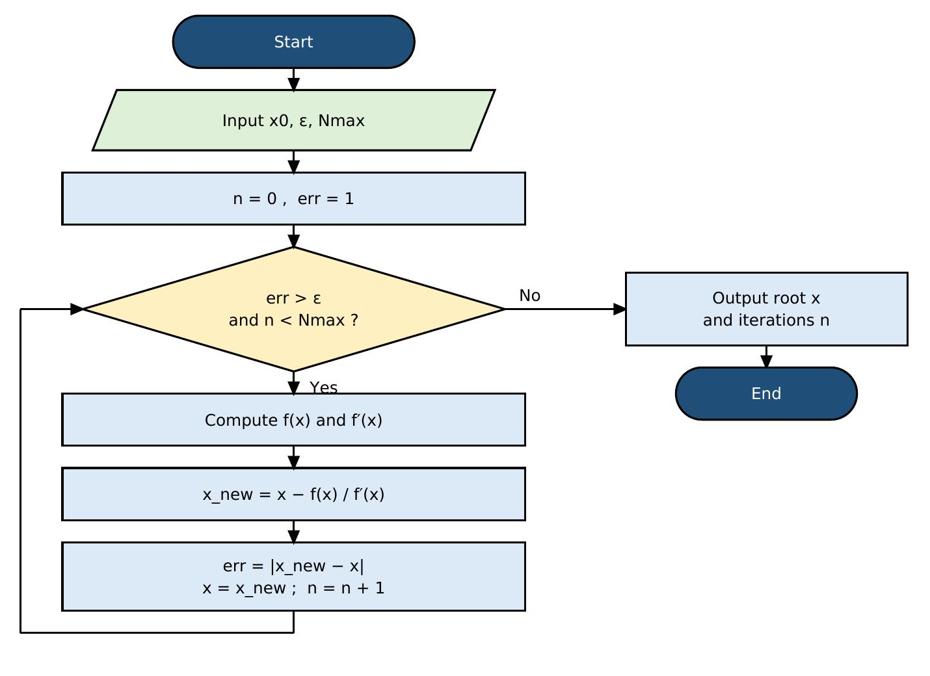

How it works
While-loop version shown. In the for-loop version the test is replaced by the counter n = 1 … Nmax, with an early exit (break) when err ≤ ε.

Q1 Pseudocode

“for” loop
INPUT x0, eps, Nmax
DEFINE f(x) = 1 - 3x + 0.5*x*e^x
DEFINE f'(x) = 0.5*(1 + x)*e^x - 3
x ← x0
FOR n = 1 TO Nmax DO
x_new ← x - f(x) / f'(x)
err ← |x_new - x|
OUTPUT n, x_new, err
IF err ≤ eps THEN
OUTPUT "Root =", x_new
STOP
END IF
x ← x_new
END FOR
OUTPUT "No convergence in Nmax steps"

“while” loop
INPUT x0, eps, Nmax
DEFINE f(x) = 1 - 3x + 0.5*x*e^x
DEFINE f'(x) = 0.5*(1 + x)*e^x - 3
x ← x0 ; n ← 0 ; err ← 1
WHILE err > eps AND n < Nmax DO
x_new ← x - f(x) / f'(x)
err ← |x_new - x|
x ← x_new
n ← n + 1
OUTPUT n, x, err
END WHILE
OUTPUT "Root =", x

Q1 Code – “for” loop (MATLAB)
% Q1: Newton-Raphson (FOR loop) f(x) = 1 - 3x + 0.5*x*e^x
clear; clc;
f = @(x) 1 - 3*x + 0.5*x.*exp(x);
df = @(x) 0.5*(1 + x).*exp(x) - 3;
tol = 0.000005; Nmax = 50;
starts = [0.5, 1.6];
for s = 1:numel(starts)
x = starts(s);
fprintf('x0 = %.1f\n', x);
fprintf('%2d %10.6f\n', 0, x);
for n = 1:Nmax
x_new = x - f(x)/df(x);
err = abs(x_new - x);
fprintf('%2d %10.6f %10.6f\n', n, x_new, err);
x = x_new;
if err <= tol
break
end
end
fprintf('Root = %.5f\n\n', x);
end

Q1 Code – “while” loop (MATLAB) and output
% Q1: Newton-Raphson (WHILE loop) f(x) = 1 - 3x + 0.5*x*e^x
clear; clc;
f = @(x) 1 - 3*x + 0.5*x.*exp(x);
df = @(x) 0.5*(1 + x).*exp(x) - 3;
tol = 0.000005; Nmax = 50;
starts = [0.5, 1.6];
for s = 1:numel(starts)
x = starts(s); n = 0; err = 1;
fprintf('x0 = %.1f\n', x);
fprintf('%2d %10.6f\n', 0, x);
while err > tol && n < Nmax
x_new = x - f(x)/df(x);
err = abs(x_new - x);
x = x_new;
n = n + 1;
fprintf('%2d %10.6f %10.6f\n', n, x, err);
end
fprintf('Root = %.5f\n\n', x);
end

Output (same for both loops)
x0 = 0.5
0 0.500000
1 0.450200 0.049800
2 0.451541 0.001341
3 0.451542 0.000001
Root = 0.45154

x0 = 1.6
0 1.600000
1 1.552769 0.047231
2 1.549552 0.003217
3 1.549538 0.000014
4 1.549538 0.000000
Root = 1.54954

Question 2: Secant Method
Find the positive solution of f(x) = x − 2 sin x = 0 by the secant method, starting with x₀ = 2 and x₁ = 1.9.
Secant formula: x_{n+1} = x_{n} − f(x_{n})(x_{n} − x_{n−1}) / (f(x_{n}) − f(x_{n−1})) = x_{n} − N_{n} / D_{n}
where N_{n} = f(x_{n})(x_{n} − x_{n−1}) and D_{n} = f(x_{n}) − f(x_{n−1}), with f(x) = x − 2 sin x.
Stopping rule: |x_{n+1} − x_{n}| < 0.0000005 (six decimal places). Starting values: x₀ = 2, x₁ = 1.9.

Q2 Solution – Secant iterations
n | x_{n−1} | x_{n} | N_{n} | D_{n} | |x_{n+1} − x_{n}|
1 | 2.000000 | 1.900000 | -7.400e-04 | -1.740e-01 | 0.004253
2 | 1.900000 | 1.895747 | -1.763e-06 | -6.985e-03 | 0.000252
3 | 1.895747 | 1.895495 | -2.719e-10 | -4.136e-04 | 0.000001
4 | 1.895495 | 1.895494 | -1.037e-16 | -1.077e-06 | 0.000000

- The positive root is x = 1.895494 (correct to 6 d.p.).
- No derivative is needed; only two starting values, and convergence is faster than linear.

Q2 Flowchart – Secant Method
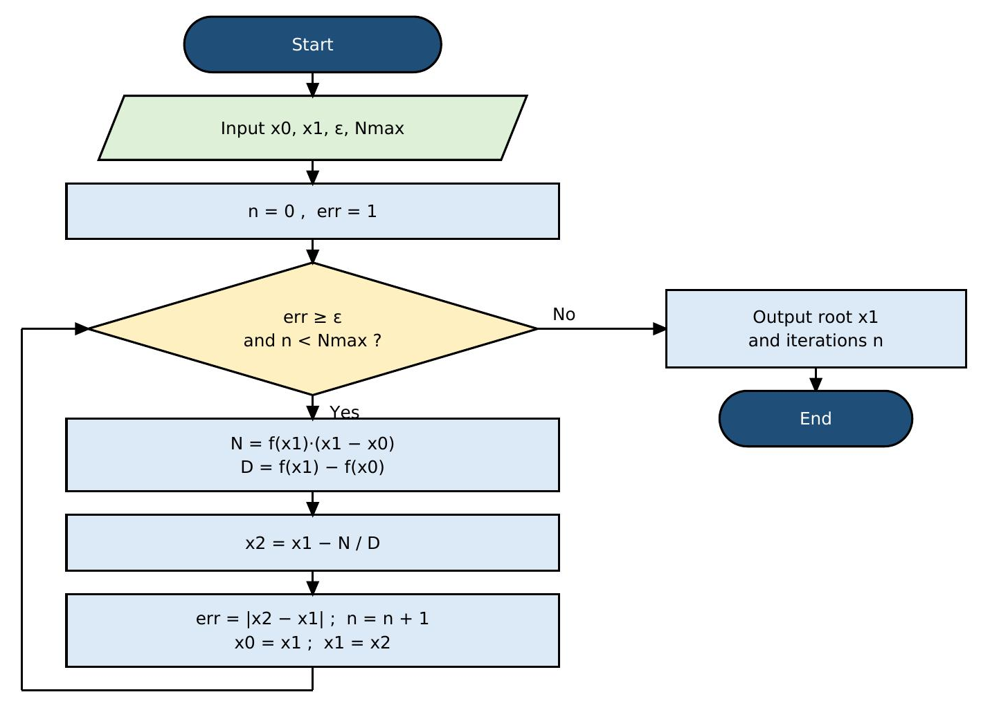

How it works
While-loop version shown. In the for-loop version the test is replaced by the counter n = 1 … Nmax, with an early exit (break) when err < ε.

Q2 Pseudocode

“for” loop
INPUT x0, x1, eps, Nmax
DEFINE f(x) = x - 2*sin(x)
FOR n = 1 TO Nmax DO
N ← f(x1) * (x1 - x0)
D ← f(x1) - f(x0)
IF D = 0 THEN STOP
x2 ← x1 - N / D
err ← |x2 - x1|
OUTPUT n, x0, x1, N, D, err
IF err < eps THEN
OUTPUT "Root =", x2
STOP
END IF
x0 ← x1
x1 ← x2
END FOR

“while” loop
INPUT x0, x1, eps, Nmax
DEFINE f(x) = x - 2*sin(x)
n ← 0 ; err ← 1
WHILE err ≥ eps AND n < Nmax DO
N ← f(x1) * (x1 - x0)
D ← f(x1) - f(x0)
IF D = 0 THEN STOP
x2 ← x1 - N / D
err ← |x2 - x1|
n ← n + 1
OUTPUT n, x0, x1, N, D, err
x0 ← x1
x1 ← x2
END WHILE
OUTPUT "Root =", x1

Q2 Code – “for” loop (MATLAB)
% Q2: Secant method (FOR loop) f(x) = x - 2 sin(x), x0 = 2, x1 = 1.9
clear; clc;
f = @(x) x - 2*sin(x);
x0 = 2; x1 = 1.9; tol = 0.0000005; Nmax = 50;
for n = 1:Nmax
N = f(x1)*(x1 - x0);
D = f(x1) - f(x0);
if D == 0
break
end
x2 = x1 - N/D;
err = abs(x2 - x1);
fprintf('%2d %9.6f %9.6f %11.3e %11.3e %10.6f\n', n, x0, x1, N, D, err);
x0 = x1; x1 = x2;
if err < tol
break
end
end
fprintf('Root = %.6f\n', x1);

Q2 Code – “while” loop (MATLAB) and output
% Q2: Secant method (WHILE loop) f(x) = x - 2 sin(x), x0 = 2, x1 = 1.9
clear; clc;
f = @(x) x - 2*sin(x);
x0 = 2; x1 = 1.9; tol = 0.0000005; Nmax = 50;
n = 0; err = 1;
while err >= tol && n < Nmax
N = f(x1)*(x1 - x0);
D = f(x1) - f(x0);
if D == 0
break
end
x2 = x1 - N/D;
err = abs(x2 - x1);
n = n + 1;
fprintf('%2d %9.6f %9.6f %11.3e %11.3e %10.6f\n', n, x0, x1, N, D, err);
x0 = x1; x1 = x2;
end
fprintf('Root = %.6f\n', x1);

Output (same for both loops)
1 2.000000 1.900000 -7.400e-04 -1.740e-01 0.004253
2 1.900000 1.895747 -1.763e-06 -6.985e-03 0.000252
3 1.895747 1.895495 -2.719e-10 -4.136e-04 0.000001
4 1.895495 1.895494 -1.037e-16 -1.077e-06 0.000000
Root = 1.895494

Question 3: Fourth-Order Runge–Kutta (RK4)
Example 4.5.3: Use the fourth-order Runge–Kutta algorithm with step size h = 0.2 to solve the initial value problem dy/dx + 2y = sin 3x with y(0) = 1 in the interval 0 ≤ x ≤ 2.4.
Rewrite as dy/dx = f(x, y) = sin 3x − 2y, x₀ = 0, y₀ = 1, h = 0.2 (12 steps to reach x = 2.4).
RK4 formulas: k₁ = h f(x_{n}, y_{n}), k₂ = h f(x_{n} + h/2, y_{n} + k₁/2), k₃ = h f(x_{n} + h/2, y_{n} + k₂/2), k₄ = h f(x_{n} + h, y_{n} + k₃)
y_{n+1} = y_{n} + (k₁ + 2k₂ + 2k₃ + k₄) / 6
First step (x₀ = 0, y₀ = 1): k₁ = -0.400000, k₂ = -0.260896, k₃ = -0.288717, k₄ = -0.171585 ⇒ y₁ = 0.721532.

Q3 Solution – RK4 (h = 0.2)

Step-by-step RK4 computation (h = 0.2)
n | x_{n} | y_{n} | k₁ | k₂ | k₃ | k₄ | y_{n+1}
0 | 0.0 | 1.000000 | -0.400000 | -0.260896 | -0.288717 | -0.171585 | 0.721532
1 | 0.2 | 0.721532 | -0.175684 | -0.096810 | -0.112585 | -0.057171 | 0.612924
2 | 0.4 | 0.612924 | -0.058762 | -0.033918 | -0.038887 | -0.034845 | 0.573054
3 | 0.6 | 0.573054 | -0.034452 | -0.049689 | -0.046642 | -0.075472 | 0.522623
4 | 0.8 | 0.522623 | -0.073957 | -0.108782 | -0.101817 | -0.140099 | 0.416748
5 | 1.0 | 0.416748 | -0.138475 | -0.170553 | -0.164138 | -0.189548 | 0.250514
6 | 1.2 | 0.250514 | -0.188710 | -0.200017 | -0.197755 | -0.195418 | 0.053902
7 | 1.4 | 0.053902 | -0.195876 | -0.177891 | -0.181488 | -0.148198 | -0.123237
8 | 1.6 | -0.123237 | -0.149938 | -0.105880 | -0.114692 | -0.059381 | -0.231648
9 | 1.8 | -0.231648 | -0.061894 | -0.005099 | -0.016458 | 0.043359 | -0.241923
10 | 2.0 | -0.241923 | 0.040886 | 0.091955 | 0.081741 | 0.126381 | -0.156146
11 | 2.2 | -0.156146 | 0.124767 | 0.153193 | 0.147508 | 0.162189 | -0.008087

RK4 result compared with the exact solution
n | x_{n} | y_{n} (RK4) | y exact | |error|
0 | 0.0 | 1.000000 | 1.000000 | 0.000000
1 | 0.2 | 0.721532 | 0.721415 | 0.000116
2 | 0.4 | 0.612924 | 0.612790 | 0.000134
3 | 0.6 | 0.573054 | 0.572955 | 0.000100
4 | 0.8 | 0.522623 | 0.522573 | 0.000050
5 | 1.0 | 0.416748 | 0.416737 | 0.000011
6 | 1.2 | 0.250514 | 0.250517 | 0.000003
7 | 1.4 | 0.053902 | 0.053892 | 0.000010
8 | 1.6 | -0.123237 | -0.123279 | 0.000042
9 | 1.8 | -0.231648 | -0.231725 | 0.000077
10 | 2.0 | -0.241923 | -0.242022 | 0.000100
11 | 2.2 | -0.156146 | -0.156244 | 0.000098
12 | 2.4 | -0.008087 | -0.008157 | 0.000070

- y(2.4) ≈ −0.008087 by RK4.
- Exact solution y = (2 sin 3x − 3 cos 3x)/13 + (16/13)e^{−2x} gives −0.008157, so the largest error is about 1 × 10⁻⁴.

Q3 Flowchart – Fourth-Order Runge–Kutta (RK4)
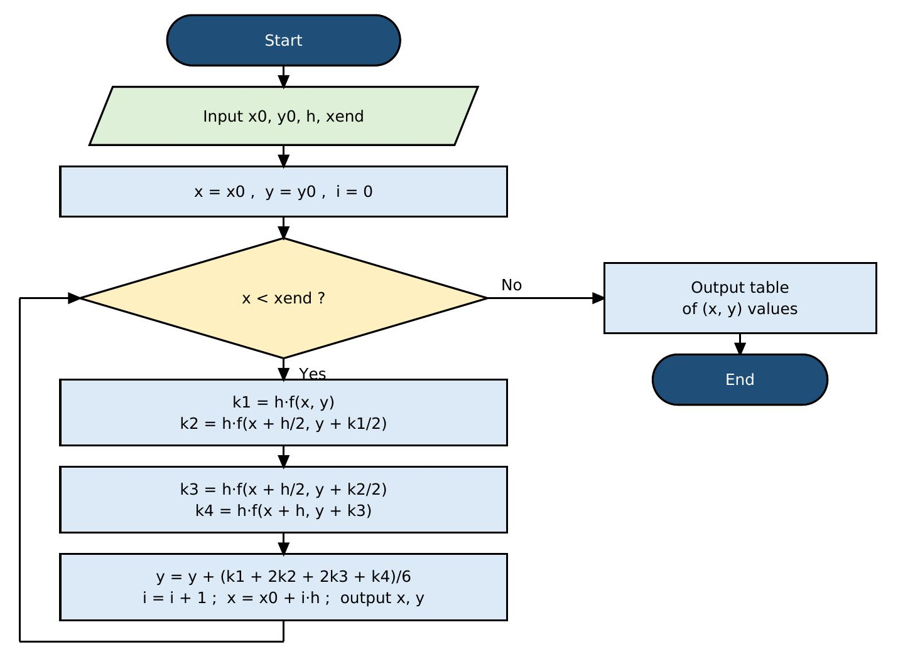

How it works
While-loop version shown. In the for-loop version the test is replaced by the counter i = 1 … steps.

Q3 Pseudocode

“for” loop
INPUT x0, y0, h, xend
DEFINE f(x, y) = sin(3x) - 2y
steps ← (xend - x0) / h
x ← x0 ; y ← y0
OUTPUT 0, x, y
FOR i = 1 TO steps DO
k1 ← h * f(x, y)
k2 ← h * f(x + h/2, y + k1/2)
k3 ← h * f(x + h/2, y + k2/2)
k4 ← h * f(x + h, y + k3)
y ← y + (k1 + 2*k2 + 2*k3 + k4) / 6
x ← x0 + i*h
OUTPUT i, x, y
END FOR

“while” loop
INPUT x0, y0, h, xend
DEFINE f(x, y) = sin(3x) - 2y
x ← x0 ; y ← y0 ; i ← 0
OUTPUT 0, x, y
WHILE x < xend DO
k1 ← h * f(x, y)
k2 ← h * f(x + h/2, y + k1/2)
k3 ← h * f(x + h/2, y + k2/2)
k4 ← h * f(x + h, y + k3)
y ← y + (k1 + 2*k2 + 2*k3 + k4) / 6
i ← i + 1
x ← x0 + i*h
OUTPUT i, x, y
END WHILE

Q3 Code – “for” loop (MATLAB)
% Q3: Runge-Kutta 4 (FOR loop) dy/dx = sin(3x) - 2y, y(0) = 1, h = 0.2, 0<=x<=2.4
clear; clc;
f = @(x,y) sin(3*x) - 2*y;
x0 = 0; y0 = 1; h = 0.2; xend = 2.4;
steps = round((xend - x0)/h);
x = x0; y = y0;
fprintf('%2d %4.1f %10.6f\n', 0, x, y);
for i = 1:steps
k1 = h*f(x, y);
k2 = h*f(x + h/2, y + k1/2);
k3 = h*f(x + h/2, y + k2/2);
k4 = h*f(x + h, y + k3);
y = y + (k1 + 2*k2 + 2*k3 + k4)/6;
x = x0 + i*h;
fprintf('%2d %4.1f %10.6f\n', i, x, y);
end

Q3 Code – “while” loop (MATLAB) and output
% Q3: Runge-Kutta 4 (WHILE loop) dy/dx = sin(3x) - 2y, y(0) = 1, h = 0.2, 0<=x<=2.4
clear; clc;
f = @(x,y) sin(3*x) - 2*y;
x0 = 0; y0 = 1; h = 0.2; xend = 2.4;
x = x0; y = y0; i = 0;
fprintf('%2d %4.1f %10.6f\n', i, x, y);
while x < xend - 1e-9
k1 = h*f(x, y);
k2 = h*f(x + h/2, y + k1/2);
k3 = h*f(x + h/2, y + k2/2);
k4 = h*f(x + h, y + k3);
y = y + (k1 + 2*k2 + 2*k3 + k4)/6;
i = i + 1;
x = x0 + i*h;
fprintf('%2d %4.1f %10.6f\n', i, x, y);
end

Output (same for both loops)
0 0.0 1.000000
1 0.2 0.721532
2 0.4 0.612924
3 0.6 0.573054
4 0.8 0.522623
5 1.0 0.416748
6 1.2 0.250514
7 1.4 0.053902
8 1.6 -0.123237
9 1.8 -0.231648
10 2.0 -0.241923
11 2.2 -0.156146
12 2.4 -0.008087

Summary of Results
Method | Problem | Result
Newton–Raphson | f(x) = 1 − 3x + ½ x e^{x} | x = 0.45154 and x = 1.54954
Secant | f(x) = x − 2 sin x | x = 1.895494
Runge–Kutta (RK4) | dy/dx + 2y = sin 3x, y(0) = 1 | y(2.4) ≈ −0.008087

